Basic Training

FT NavVision©

Day 2

Version 1.1 ● December 27, 2013

Connections od I/O, Simulation I/O, processing I/O, Configuration I/O, Configuration Alarms, Calibration

**Last edited: 27 December 2013**

**Copyright © 2011 FT NavVision© . All rights reserved.**

**No part of this publication may be reproduced, transmitted, transcribed, stored in a retrieval system, or translated into any language, in any form or by any means, electronic, mechanical, photocopying, recording, or otherwise, without prior written permission FT NavVision© .**

**All copyright, confidential information, patents, design rights and all other intellectual property rights of whatsoever nature contained herein are and shall remain the sole and exclusive property of FT NavVision© . The information furnished herein is believed to be accurate and reliable.**

**However, no responsibility is assumed by FT NavVision© for its use, or for any infringements of patents or other rights of third parties resulting from its use.**

**The FT NavVision© name and FT NavVision© logo are trademarks or registered trademarks of FT NavVision©**

**All other trademarks are the property of their respective owners**

|  |  |
| --- | --- |
| Publication type: | Training |
| Publication number: | FTT1301002 |
| Title: | Basic training FT NavVision® day 2 |
| Subject: |  |
| Issue: | 1.1 |
| Publication date: | February 19, 2013 |
| Total number of pages: | 39 |
| Author: |  |

Inhoud

1. Introduction 6

2. Connection of i/o basics 6

2.1 Basics 6

3. Simulation AI/DI/DO 6

3.1 Wago 6

3.1.1 DI 7

3.1.2 DO 8

3.1.3 AI/AO 9

3.2 Configuring I/O 10

3.2.1 Power consumption 11

3.3 Wago 13

3.3.1 General 13

3.3.2 Adding a field to the Wago 14

3.3.3 Wago “Type” explanation 15

3.3.4 Type and behavior 16

3.3.4.1 Alarm 16

3.3.4.2 Alarm Buzzer 16

3.3.4.3 Alarm Status 17

3.3.4.4 Auto 17

3.3.4.5 Closed 17

3.3.4.6 Failure 17

3.3.4.7 High 17

3.3.4.8 High Level 17

3.3.4.9 Impulse 17

3.3.4.10 Lamp 17

3.3.4.11 Low 17

3.3.4.12 Low Level 18

3.3.4.13 Off Lamp 18

3.3.4.14 On Lamp 18

3.3.4.15 Open 18

3.3.4.16 Pending 18

3.3.4.17 Pulse 18

3.3.4.18 Push 18

3.3.4.19 Ready 18

3.3.4.20 Remote 18

3.3.4.21 Request 18

3.3.4.22 Reset (Request) 18

3.3.4.23 Running 19

3.3.4.24 Running Hours 19

3.3.4.25 Set (Request) 19

3.3.4.26 Standard 19

3.3.4.27 Standby 19

3.3.4.28 Status 19

3.3.4.29 Switch 19

3.3.4.30 Timeout 20

3.3.4.31 Too High 20

3.3.4.32 Too High Level 20

3.3.4.33 Too Low 20

3.3.4.34 Too Low Level 20

3.3.5 Wago Device Manager 20

3.3.6 Wago calibration 23

3.4 Tank Tables 26

3.4.1 General, 26

3.4.2 types of sensors 26

3.4.2.1 Floating sensor 26

3.4.2.2 Capacitive sensor 27

3.4.2.3 Pressure sensor 27

3.4.3 Calculations 29

3.4.4 Offset 29

3.4.5 Inserting sounding tables 30

3.4.5.1 Tank Group 31

3.4.5.2 Excel import 32

3.4.5.3 Import from excel 34

3.4.6 Trim and List 35

3.4.6.1 Roll and Pitch in the Tank Table 36

3.4.6.2 Trim and list in Excel 37

Figures

Figure 3‑1: Operating mode switch (Wago) 7

Figure 3‑2: Datasheet 8

Figure 3‑3: Bilge switch 9

Figure 3‑4: 750-523 9

Figure 3‑5: 750-517 10

Figure 3‑6: 750-454 10

Figure 3‑7: 750-461 11

Figure 3‑8: 750-483 11

Figure 3‑9: Datasheet PLC 12

Figure 3‑10: consumption 750-430 13

Figure 3‑11: consumption 750-454 13

Figure 3‑12: 750-613 13

Figure 11‑43: Wago configuration 14

Figure 11‑44: Wago expanded view 15

Figure 11‑45: Sensor-window 16

Figure 11‑46: Sensor type list 17

Figure 11‑47: Wago Device Manager 22

Figure 11‑48: Device Manager 23

Figure 11‑49: Operating mode switch (Wago) 24

Figure 11‑50: Calibration 25

Figure 11‑51: Graph (WAGO calibration) 26

Figure 11‑52: Graph Calibrated 27

Figure 11‑60: Tank Pressure Sensor 29

Figure 11‑61: Tune table 30

Figure 11‑62: adjusted tune table 31

Figure 11‑63: Tank Tables 31

Figure 11‑64: Tank Group Drop Down 32

Figure 11‑65: Filling in tank tables 32

Figure 11‑66: Excel tabs 33

Figure 11‑67: Example Sounding Table 33

Figure 11‑68: Excel sheet import list 34

Figure 11‑69: Excel list sorted 35

Figure 11‑70: Imported Table 36

Figure 11‑71: Roll and Pitch 37

Figure 11‑72: Max Trim 37

Figure 11‑73: Max List 38

Figure 11‑74: Trim/List example 38

Figure 11‑75: trim and list excel example 39

Figure 11‑76: Tank Table excel Trim and List import 40

Tables

Table 3‑1: Wago adjustment 8

Table 11‑1: Pressure sensor explanation 29

Table 11‑2: Tank Tables 32

# Introduction

The main event with which FT NavVision® is working is the fact that we monitor all kinds of I/O. Whether it is through serial, TCP/IP or Canbus and regardless of which protocol is used, FT NavVision® can convert it into a mimic on the HMI. You can understand that a more than common knowledge is required to make sure that all these I/O’s are connected and set-up properly. In the training today, we will try to give you the basic knowledge of these connections.

# Connection of i/o basics

## Basics

While we go more in depth on the divers connections and protocols in a later stage of this training, we now will merely touch the raw connection of I/O at its basics.

In fact we only have 2 real connection methods to the PC and that is serial and Ethernet. We can extend that by saying that we have Serial to Ethernet interfaces or CAN to Ethernet interfaces. Also we can say that through the Ethernet it can be TCP/IP, Modbus and more But we will see that later on.

For now we will concentrate on the more basic I/O’s because we would like to show you how it is processed in FT NavVision®. Therefor we will take the WAGO PLC as an example. We will show you how analogue and digital I/O’s are passing through the FT NavVision® system and how we can manipulate them

# Simulation AI/DI/DO

## Wago

We use almost only Wago PLC’s for our connections of AI/DI/DO etc. This is because it has been proven for the last 15 years that it is very reliable. Therefore we are going to discuss the connections to a Wago PLC here today.

We do have an example of a Wago PLC here. The first thing that is important is the way it is connected to the system. For that we use an Ethernet cable that is commonly connected to a switch which subsequently is connected to the servers.

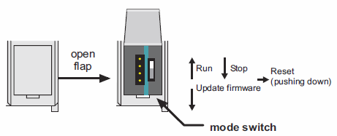

Figure 3‑1: Operating mode switch (Wago)

The operating mode switch (see Figure 3‑1) is a push/slide switch with 3 settings and a hold-to-run function.

|  |  |
| --- | --- |
| **Operating mode switch** | **Function** |
| From center to top position | Activate program processing (RUN) |
| From top to center position | Stop program processing (STOP) |
| Lower, bootstrap | For original loading of firmware, not necessary for user |
| Push down (i.e. with screwdriver) | Hardware reset.  All outputs and flags are reset; variables are reset to 0 or to FALSE or to an initial value.  Retain variables or flags are not changed.  The hardware reset can be performed with STOP as well as RUN in any position of the operating mode switch! |

Table 3‑1: Wago adjustment

### DI

A DI or digital in, is an incoming signal that can be either high or low (1 or 0). The most commonly used Wago slice is the 750-430. This is an 8-channel DI module. Of course we have smaller and bigger modules, but we leave it at this now while it is more a financial or logistic issue.

The second thing you need to know is that you have two types: either it is “high side switching” or “low side switching” . this just means if the module reacts to a positive or a negative voltage. The high side switching is the most commonly used, but we do have systems where we need to switch to 0.

On the site of Wago you can find the datasheets of all modules. So if you need to know something, just download the datasheet.

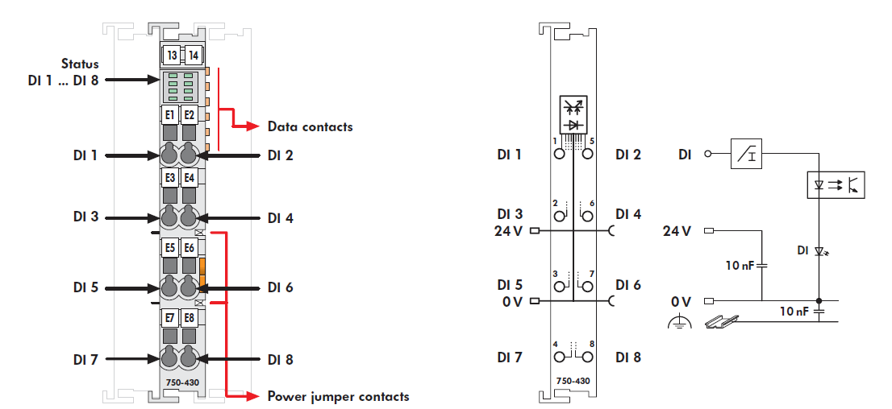

Figure 3‑2: Datasheet

According to Figure 3‑2 you can tell that this module has 8 DI. So in this case you can attach 8 sensors on it that react as a switch for example.

Now let’s say that we are going to use this module to attach the alarms from bilges. So to trigger this I/O we need to connect a power through the bilge contact to the entry of the Wago module. We will take pin 1 as example.

*: make sure that you feed the sensor with the same power supply as you feed the Wago.*

From the power supply we feed 24V to the sensor switch the other side of the switch we run to pin 1 on the Wago. Now when the bilge-sensor closes it lets the power through which will put the entry of pin 1 high.

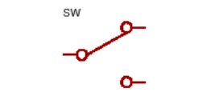

Figure 3‑3: Bilge switch

*: there is a difference if the sensor is wired NC instead of NO. This can be changed in FT NavVision®.*

At the point where pin 1 gets high FT NavVision® will handle the rest depending on what is configured on that field.

This is the basic way to connect any kind of DI to a Wago module.

### DO

DO or digital output works the opposite way. If there is an output triggered the Wago will send a 24V output. This can be used to trigger a relay or as a switch to directly switch on a sensor or other peripheral.

There are various kinds of DO modules. Depending on what you would like to do with it, you can choose from normal DO to potential free DO and even switches that can handle a larger voltage such as the 750-523 module.

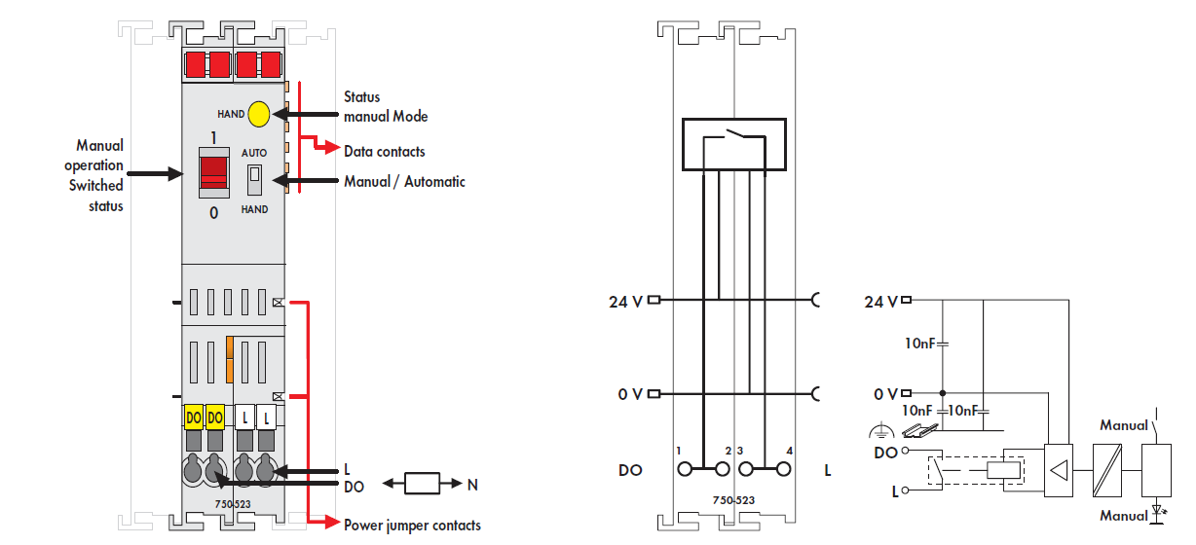

Figure 3‑4: 750-523

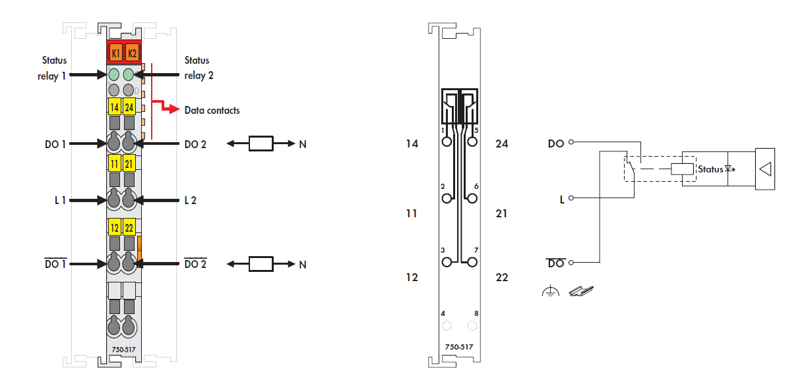

Figure 3‑5: 750-517

### AI/AO

Also in the analogue field you have a wide Variety of modules. Most commonly used is the 750-454 which is a 4-20 mA module. This module measures the incoming current and makes that value available on the bus so FT NavVision® can use that. Other AI modules measure voltage or resistance. These modules can be found on the WAGO website with their respective datasheets.

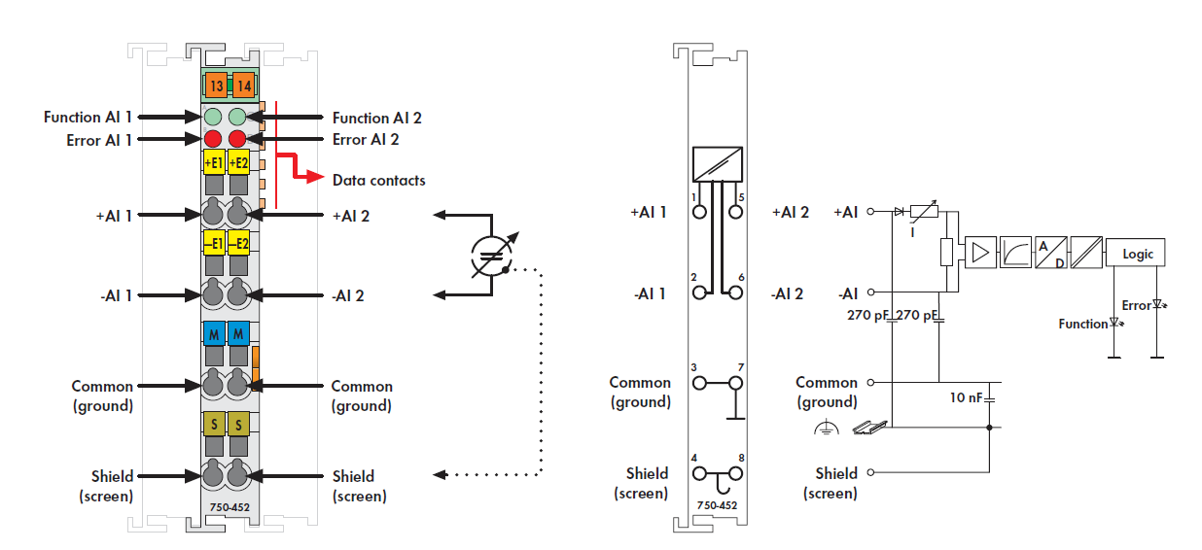

Figure 3‑6: 750-454

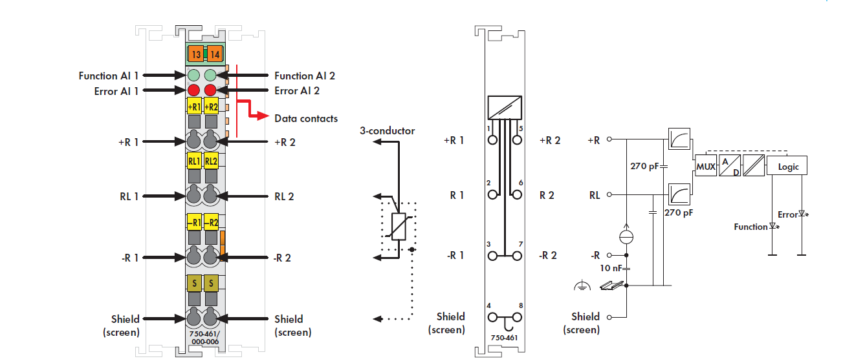

Figure 3‑7: 750-461

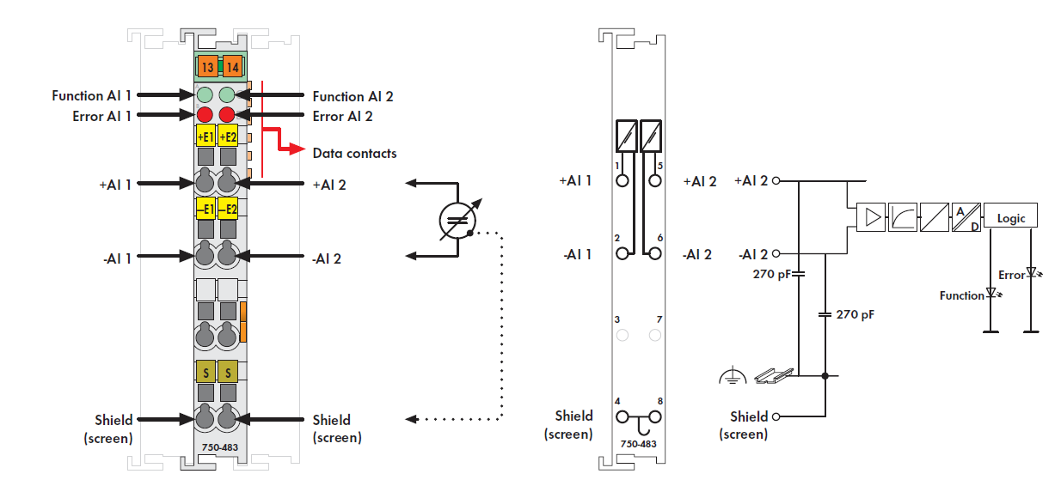

Figure 3‑8: 750-483

## Configuring I/O

Looking at the datasheets you can notice a few things. For the configuration of a complete Wago module it is important that you follow the right order. It isn’t written in stone but FT NavVision® uses the following sequence:

* DO
* DI
* AO
* AI

This is done especially for the connection of the power supply and the data contacts. Looking at the datasheets you will notice that some of the modules have a power supply that is running from one side to the other. So the module in front and the module after can be supplied by the same line. If you, however, put a module in between that haven’t got these lines, the power supply after that module will stop.

This goes the same for the data contacts. Some modules do not have the data contacts and need to be at the end of the line. Take good notice of this when you put together a wago PLC.

### Power consumption

The other thing is power consumption. A complete wago PLC can only handle a maximum amount of slices and a maximum amount of power consumption. This can be found in the datasheet of the specific PLC.

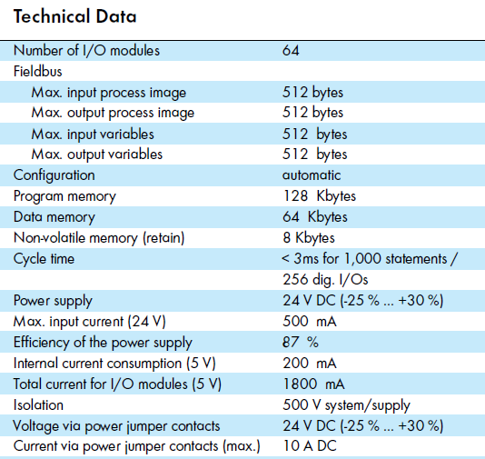

Figure 3‑9: Datasheet PLC

As you can see you can only add 64 additional I/O modules behind the PLC. The total current it can handle is 1800mA minus the 200mA it uses itself. So you have an additional 1600mA for the other I/O modules.

When putting together a Wago, please refer to the datasheets of the I/O modules to see how much internal current consumption they have. Add this for all the modules you need and than calculate if you do not exceed the maximum.

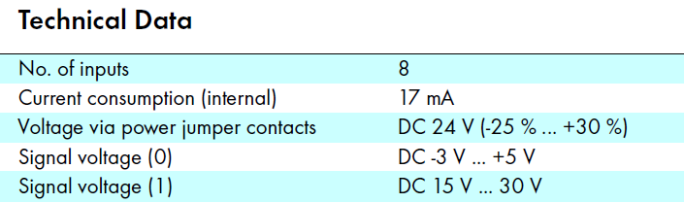

Figure 3‑10: consumption 750-430

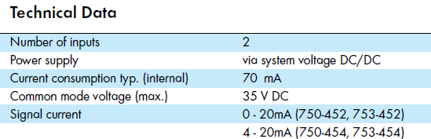

Figure 3‑11: consumption 750-454

If you exceed the maximum current you need to divide the I/O modules onto more PLC’s or you need to add another power supply module such as the 750-613.

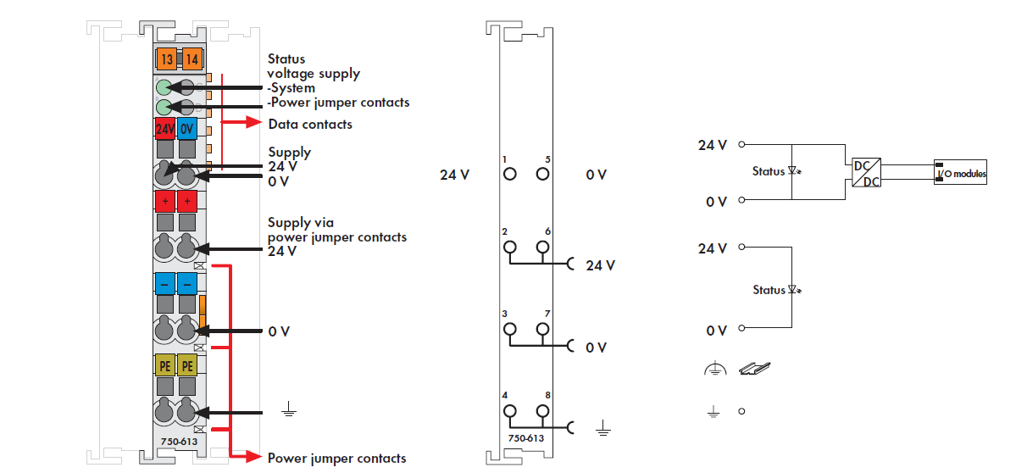

Figure 3‑12: 750-613

## Wago

### General

Under “Tools > Configuration > Wago” (see Figure 3‑13) all detected and connected Wago devices become visible including the server to which they are connected to.   
You can check the MAC-address and see if the Wago is connected or not.

In general, by means of the sensor list changes are made. But for minor changes or to improve the control of the device, please refer to this menu.

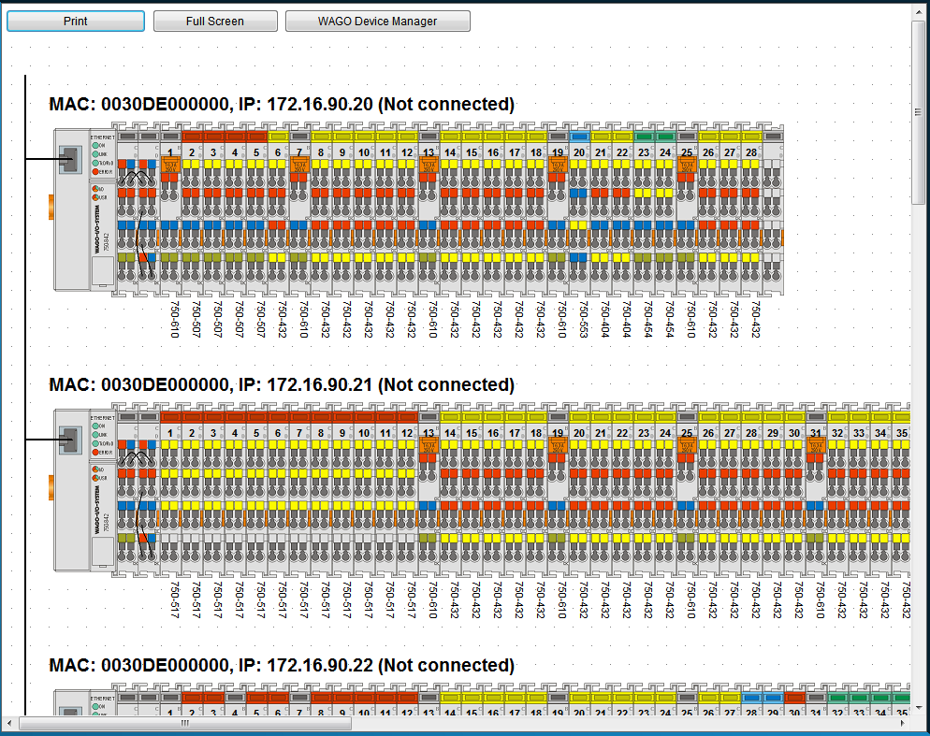

Figure 3‑13: Wago configuration

|  |  |
| --- | --- |
| **Detail** | **Description** |
| Print | Print the separate Wago-layouts for your convenience |
| Full Screen | Shows the Wago-layout full screen |
| Wago Device Manager | Opens a new window where you can set specific configuration settings |

When you click on a Wago, it will expand and show you the separate slices with the connected fields (see Figure 3‑14). Here you can fine-tune the selection, troubleshoot problems and calibrate sensors.

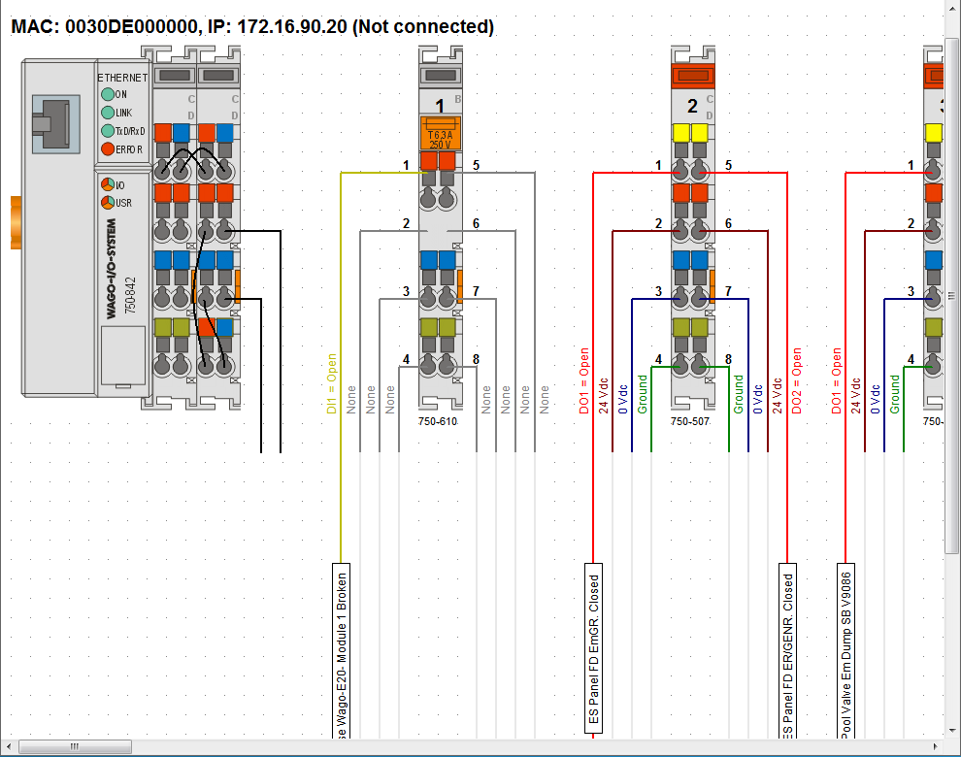

Figure 3‑14: Wago expanded view

### Adding a field to the Wago

If you want to add a new field to a Wago slice, just click on the field name box of the specific slice. If there was not already a field attached, the box will be blank (named sensor). By clicking it you will open a new window that shows all the fields within FT NavVision® (see Figure 3‑15)

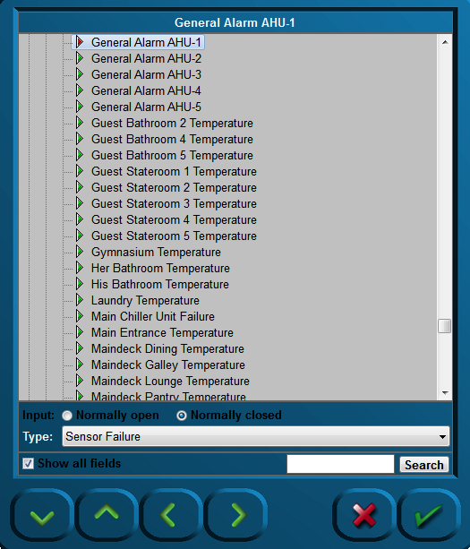

Figure 3‑15: Sensor-window

The following choices are possible:

|  |  |
| --- | --- |
| **Detail** | **Description** |
| Input | NO or NC |
| Type | The behavior of the field (see 3.3.3) |
| Show all fields | Toggling between all fields and fields available |
| Search | Search for a specific field |

### Wago “Type” explanation

The Type architecture needs some extra explanation. Each field in FT NavVision® has its own behaviour. It can be an alarm, a status, or an analogue value. Sometimes you need to give a field a specific task. As add-on to its original task, or if the field is just a standard field.

By default the sensor will have “standard” as its type-value. This will set the behavior to the standard mode of the field. The choices you have and their behavior will be explained in the next paragraph.

### Type and behavior

Under “Type” (sensor type) a variety of sensor types can be chosen. The most commonly used types are described.   
Click the arrow button of the dropdown menu to open the sensor type list (see Figure 3‑16).

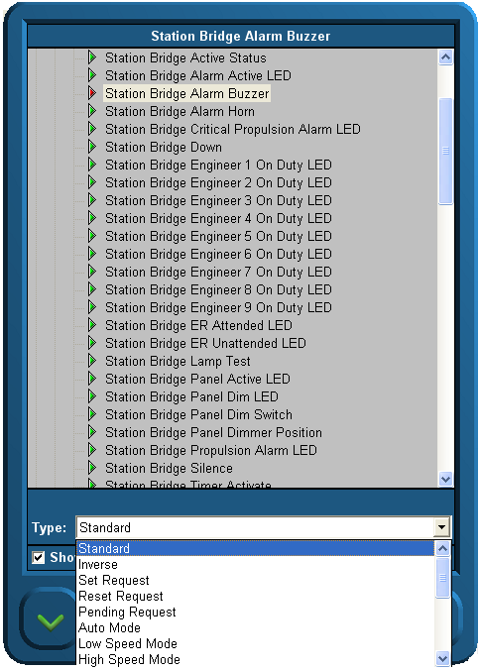

Figure 3‑16: Sensor type list

#### Alarm

If the connected field isn’t a specific alarm field (see “Field Settings > Alarm”) it is possible you still like it to act as an alarm. Just set the type to Alarm.

#### Alarm Buzzer

If a field has to react at the same pace as an alarm buzzer, you can choose this type. If you, for example, put it on an output, You can let a lamp blink as the alarm goes off.

#### Alarm Status

Sometimes you need to feed a led-board to show all the alarms on a separate place. With type Alarm Status, you can set a field to set high if this field is in alarm. This way you can feed a led-lamp.

#### Auto

Auto is used in the combination Auto/Manual. If you choose this type, you can see when a sensor is ready to be controlled through FT NavVision® .

#### Closed

Does the same as the set/reset request but then on the DI. Look at a specific sensor to find out that it is functioning. When on is detected it knows the position is closed.

#### Failure

It is the same as status, but in this case mostly used as a setting to check whether the sensor is in failure. It is used to set failure status on bulb failure or as general alarm from attached devices.

#### High

See low alarm.

#### High Level

See low alarm.

#### Impulse

If an impuls relay is connected to a DO you don’t want to generate a constant voltage. Put the status on “Impuls Relay” and the DO will give a short pulse when triggered.

#### Lamp

If, in addition to FT NavVision® , you also need to show the lights on an analogue panel, it is wise to give all the lights the type “Lamp”. This way it will be possible to use the lamp test function. By using this function, all the fields with “Lamp” as type will lit up once the lamp test is pressed. Also you can use it to test the real lights. When pressing the lamp-test button you can check all the bulbs.

#### Low

If the connected FT-field isn’t a specific alarm field (see “Field Settings > Alarm”) it is possible you still like it to act upon an alarm. For example if you have the field “Fresh water level” you could like to have an alarm when the tank is almost empty. Here is where you can put the status to “low alarm”. The system will identify it as an alarm field and will consequently show the alarm on the alarm panel and logbook. Note that it states “ext.” on the alarm panel to indicate that it is an external alarm.

#### Low Level

See low alarm.

#### Off Lamp

See Lamp.

#### On Lamp

See Lamp.

#### Open

Does the same as the set/reset request but then on the DI. Look at a specific sensor to find out it is off. When off is detected it knows the position is opened.

#### Pending

Used on a DO. Once selected it gives a signal as long as the particular task is not fulfilled. I.e. in a mimic you can show by a blinking icon that the action is still taking place.

#### Pulse

When a sensor needs a short pulse instead of a steady signal, use Type “Pulse”.

#### Push

Same as Switch, but then used as a second type for the same sensor. Also used to control the sensor through a mimic button.

#### Ready

When the sensor is ready for use, “ready” will get high.

#### Remote

Used in conjunction with Local. To see if the sensor can be controlled locally or remote.

: local is at the sensor and remote is in FT NavVision® .

#### Request

See Switch.

#### Reset (Request)

*:*

*Does not function without Digital In (DI) status.*

The “Reset request” signal output in general is a Digital Output (DO).

Once selected, a request will be set to the attached sensor (e.g. a valve or other device that can be steered to open), and it will stay set until it gets a status back that the request is fulfilled. Needs to be combined with a DI where the status of the sensor will be connected to (i.e. open/close).

#### Running

DI that is coming from the sensor to show that it is running. Used to measure the total time etc.

#### Running Hours

Internal calculation. Once the sensor is high, this field will start the count for running hours based upon the time that the sensor is high (also when switched on but not running, so less accurate).

#### Set (Request)

*:*

*Does not function without Digital In (DI) status.*

The “Set request” signal output generally is a digital output.  
Once selected, a request will be set to the attached sensor (e.g. a valve or other device that can be steered to open), and it will stay set until it gets a status back that the request is fulfilled. Needs to be combined with a DI where the status of the sensor will be connected to (i.e. open/close).

#### Standard

This is the standard setting. Via this setting nothing extra will be added to the field. Leave it on standard if nothing else is required or if you don’t know.

#### Standby

See Ready.

#### Status

Is general used on DI. If you need to know the status on an attached sensor but that sensor is in use by the PLC-program, you can use status in the Wago configuration. Now it reads the status of the sensor without interfering with the PLC-program.

#### Switch

When a switch is connected to a DI (i.e. an external pushbutton) you must set the status to switch. A box will appear which reads “request”. Now Wago will know that it has a switch connected and will act accordingly. If this status isn’t set upon a hardwired button, this button will not work.

#### Timeout

Some sensors, i.e. valves, have a separate connection to show that the action has timed out. When not available use Timeout as type. If no signal is coming back (DI) within a certain amount of time, it will give a timeout.

#### Too High

See low alarm.

#### Too High Level

See low alarm.

#### Too Low

See low alarm.

#### Too Low Level

See low alarm.

### Wago Device Manager

Under “Configuration > Wago > Wago Device Manager” the following window appears:

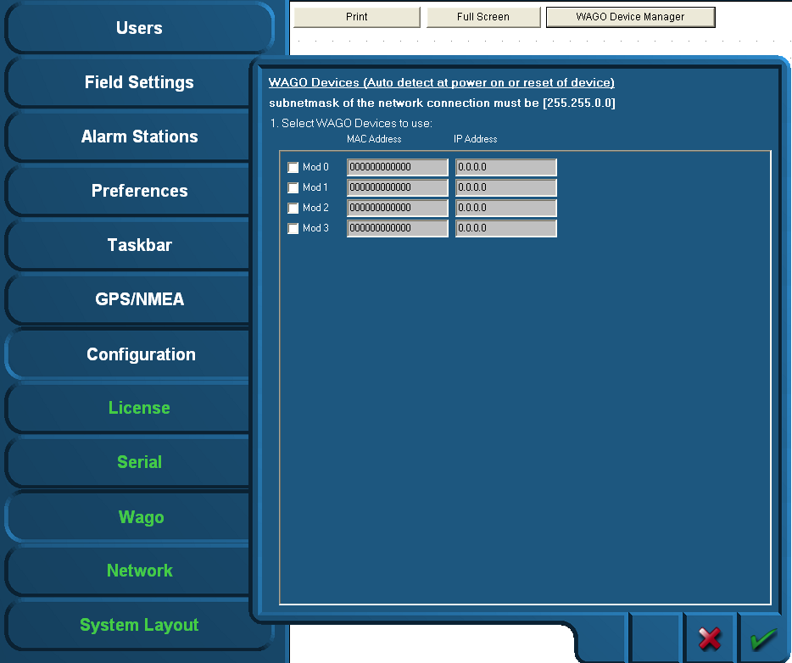

Figure 3‑17: Wago Device Manager

When the devices are correctly installed and connected, the respective MAC addresses will be shown via the “Wago Device Manager” window. The “Mod0” and others that are found are shown green. If a Wago is specified with an IP address and there is no connection, the Text will be red. (see Figure 3‑18)

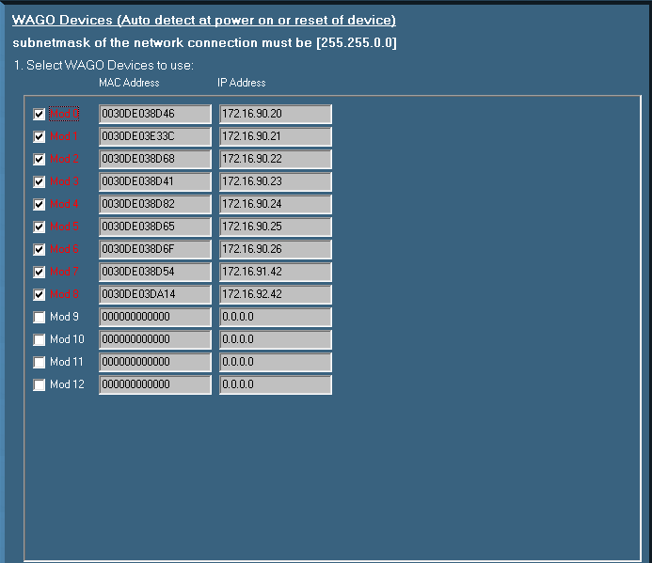

Figure 3‑18: Device Manager

If the MAC addresses does not show, it is possible that there is no connection with the specific Wago or the Wago devices need to be restarted. This can be accomplished by

* Disconnecting electrical power from the Wago device for a short period of time
* By pushing down the operating mode switch (see Figure 3‑1).



Figure 3‑19: Operating mode switch (Wago)

The operating mode switch (see Figure 3‑1) is a push/slide switch with 3 settings and a hold-to-run function.

|  |  |
| --- | --- |
| **Operating mode switch** | **Function** |
| From center to top position | Activate program processing (RUN) |
| From top to center position | Stop program processing (STOP) |
| Lower, bootstrap | For original loading of firmware, not necessary for user |
| Push down (i.e. with screwdriver) | Hardware reset.  All outputs and flags are reset; variables are reset to 0 or to FALSE or to an initial value.  Retain variables or flags are not changed.  The hardware reset can be performed with STOP as well as RUN in any position of the operating mode switch! |

If the device manager shows a MAC address, check this against the MAC address on the head station on the Wago. If it is right, click the check box.

Fill in the IP address the Wago device (must be in the same range as the PC, i.e. 172.16.x.x).  
For Wago the last digits are in the 90 range. The very first connected Wago will be set to 172.16.1.91 and the next available to 172.16.1.92 etc.

Confirm the settings by clicking the “OK” button. The screen will show the connected Wago devices, their respective MAC addresses, their given IP addresses and the server they are connected to.

### Wago calibration

In Wago you can calibrate the analogue sensors, which is especially proficient when it is non-linear. As example we’ll show the calibration of a tank.

The best steps to calibrate the tank sensors are as following:

1. Shut down all the NavVision installations (i.e. other servers and clients) except for one server. This must be done to make sure this server's calibration will not accidentally be overwritten by any other system on the network
2. On the running Server system, open the Wago configuration and follow the next steps for every field
3. Press the “W” on the (i.e 750-454) modules containing the tank level sensors. The 750-454 modules measures 4 to 20 mA (see Figure 3‑20)
4. You now see the old calibration or the standard linear one. Be aware of the measuring unit used.  
   The graph (see Figure 3‑21) shows the unity on the Y-axis; depending on the actual field settings
5. Write down the measured mA for an empty tank. The measured mA is shown below the graph.

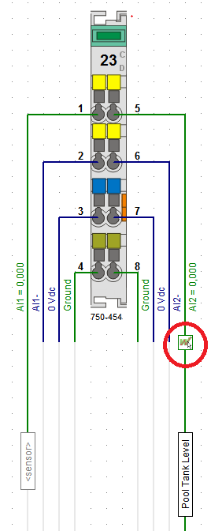

Figure 3‑20: Calibration

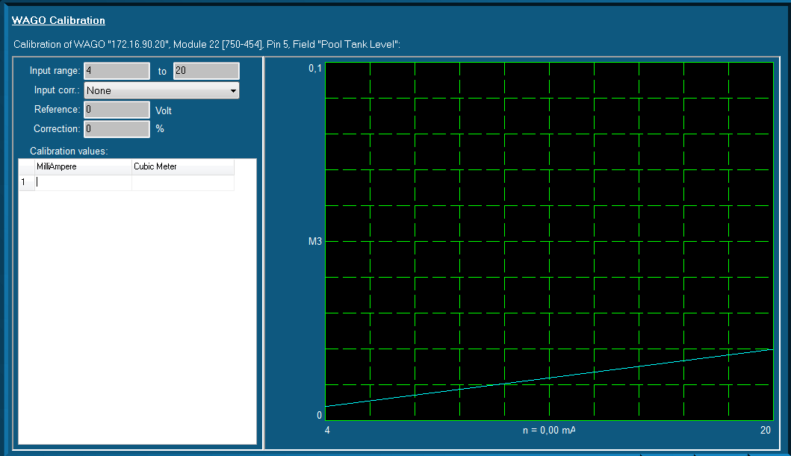

Figure 3‑21: Graph (WAGO calibration)

You can enter this value in the first row/first column of the table. In the right column, enter “0”. This column is the amount of unity's noted down in step four.

You now have configured that this amount of mA gives “0” (gallons/liters/...)

1. Fill the tank until you see the mA changing.   
   Depending on the sensor, it can be that the first amount is not measured
2. Write down this mA and amount of liters/gallons (depending on the unity) on the next row
3. Repeat the filling/noting down the values steps as much times as you like. If the tank is completely linear, four times could be a good choice. If not, it's better to make more measurements concerning the odd-shaped part of the tank
4. Finally, be sure to take a measurement with a full tank. You now see the blue line containing your calibration (see Figure 3‑22)
5. Repeat step 3 t/m 9 for every tank sensor available on the ship
6. Shut down FT NavVision® ®
7. Copy the file "cal.ini" from the "config" folder of the configured NavVision to an USB stick. This file contains all the calibrations made
8. Copy this file ("cal.ini") FROM the USB stick TO every server system on the ship.   
   Choose to overwrite the old calibration of the servers.

From this particular moment each system is calibrated.

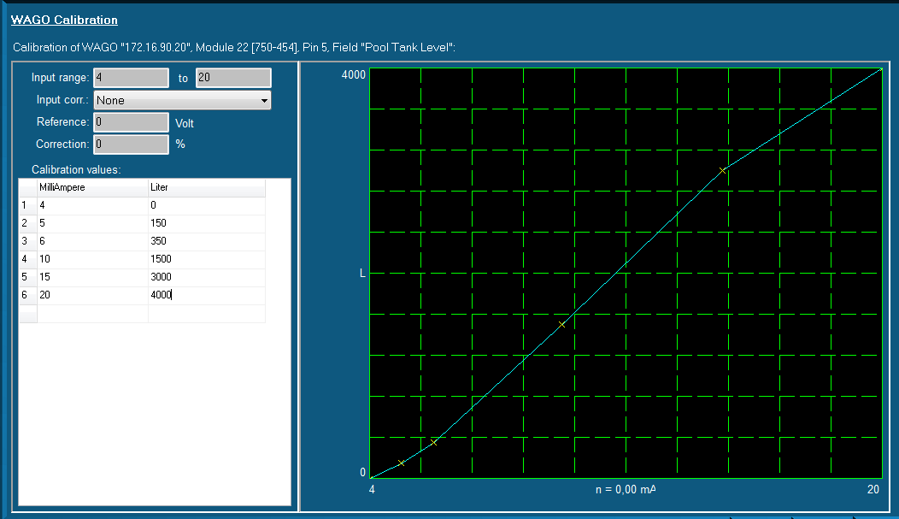

Figure 3‑22: Graph Calibrated

## Tank Tables

### General,

Each ship must have some kind of device to show the content of the divers tanks. Whether it is a glass tube, a pressure sensor, a capacitive sensor or a float unit, they are all designed to show the contents of the particular tank. While the first is a mechanical device, the rest is merely electrical.

The bigger ships will rely more on an accurate reading. Not only will they travel over longer distances, or need to be cost effective, they also often need to balance the ship by even things out in diverse ballast tanks. You can understand that the calibration of these sensors will have to be quite accurate.

### types of sensors

We will focus here on the electrical sensors as the mechanical ones gets more and more obsolete. The most used ones are

* The floating sensor
* The capacitive sensor
* The pressure sensor

#### Floating sensor

The floating sensor can be compared with the float unit that is used in toilets. These type of sensors are level-sensors. They measure how high (or low) the level of the fluid in the tank is. They can be equipped with a floating device connected to a hinged part, where the hinged part is electrically connected to a resistor which will give a voltage or milli-amperage that can be used to show the actual level of the liquid. The floating device can also be a magnetic ring attached around a pipe. For calibrating this device, please refer to Chapter 3.3.6.

#### Capacitive sensor

The principle of capacitive level measurement is based on change of capacitance. An insulated electrode acts as one plate of capacitor and the tank wall (or reference electrode in a non-metallic vessel) acts as the other plate. The capacitance depends on the fluid level. An empty tank has a lower capacitance while a filled tank has a higher capacitance. While this is also a level measuring type it can be calibrated as told in Chapter 3.3.6.

#### Pressure sensor

The pressure sensor is not a level indicator. It measures the liquid pressure (Pl) of the column of liquid above the sensor. In conjunction with the density of the liquid you can calculate the volume of the liquid. When the architect of the tanks has provided a sounding table, with the liquid pressure you can calculate the height of the liquid as well as the m3 of liquid. Again with the density you can calculate the mass (tonnage). You can see that this provides a very accurate and diverse scheme for the tanks that is very useful.

Within the FT NavVision © system all this calculations are done automatically once you provided one of the variables. (see Figure 3‑23)

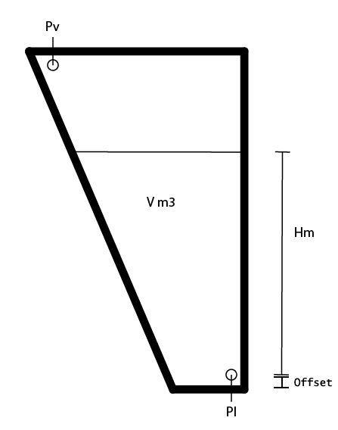

Figure 3‑23: Tank Pressure Sensor

|  |  |
| --- | --- |
| **Abrreviation** | **Explanation** |
| Pl | Liquid Pressure |
| Pv | Vent Pressure |
| V m3 | Volume in square meter |
| Hm | Height in meter |
| Offset | Offset sensor in meter |

Table 3‑2: Pressure sensor explanation

*: When not provided with a Pressure Vent Sensor it might give some strange irregularities. Especially when the vent-pipe is too small it will interfere with a good reading of the pressure sensor, while the air above the liquid column will be shifting all the time. It might then be necessary to place a Vent Pressure Sensor to even this out. Also this calculation is done automatically within FT NavVision ©.*

### Calculations

Just for your understanding we will put down the calculations we make in FT NavVision®.

Depending on which value you have, we distinct the following calculations:

Pc = Pl – Pv (mBar)

g = 9.80665 (m/s2)

D = Density (kg/m3)

|  |  |
| --- | --- |
| **Abrreviation** | **Explanation** |
| H | Height |
| Pc | Pressure column |
| g | Average gravity |
| D | Density |
| Offset | Offset sensor in meter |

### Offset

Every sensor will have an offset. None of the sensors will be exactly on the bottom of the tank. Especially when the tank expands upwards, a small offset can make a big difference when the tank is full.

When you know the offset of the sensor you can adjust this in the tune table of that particular tank. Goto Fieldsettings/tune and look for the tank that you are about to adjust. Make sure you use the “Height” value. See the following figure:

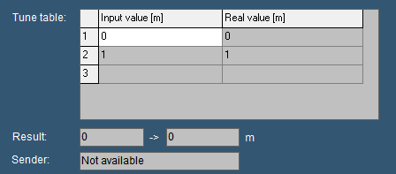

Figure 3‑24: Tune table

Now let’s say that your sensor has an offset of 20cm. This means that if the sensor reads 1 meter of height it is actually 1.2 meter.

You can adjust that by changing the input value and the real value accordingly. So now we know that if the sensor has an input value of 0m it is actually 0.2m and if the sensor has an input value of 1m it is actually 1.2m

If you change that in the tune table (see Figure 3‑25) FT NavVision® will calculate with the right values.

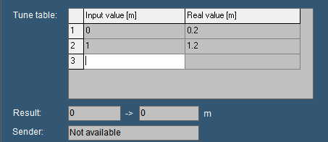

Figure 3‑25: adjusted tune table

### Inserting sounding tables

Under Configuration>Tank Tables you can find all the tanks. (see Figure 3‑26).

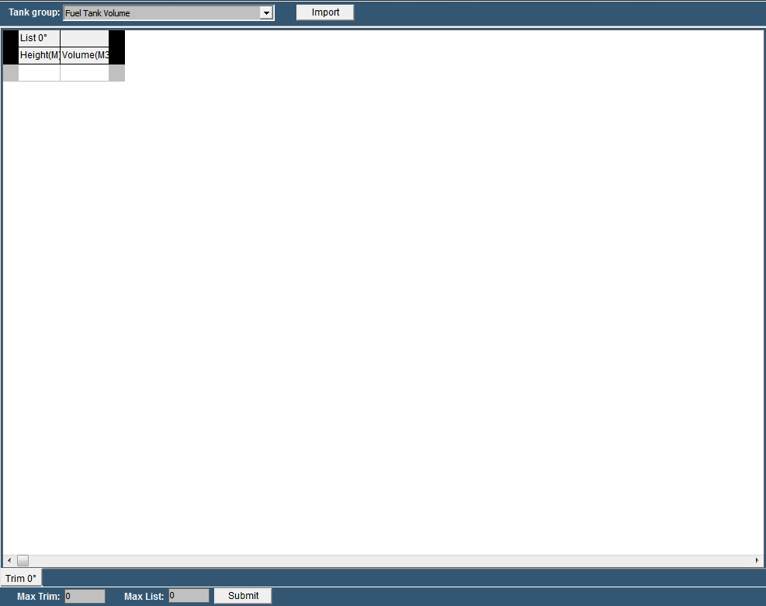

Figure 3‑26: Tank Tables

|  |  |
| --- | --- |
| **Detail** | **Description** |
| Tank Group | Find the tank you want to adjust a tank table for |
| Import | Import an Excel-sheet with sounding data |
| Max Trim | Max pitch (if provided in sounding table) |
| Max List | Max Roll (if provided in sounding table) |
| Submit | Submit Trim and List |

Table 3‑3: Tank Tables

#### Tank Group

In the drop down menu you can search for the tank that you are about to adjust. You will get all the tanks available. In this example we will use the Fuel Tank 1 Volume (see Figure 3‑27).

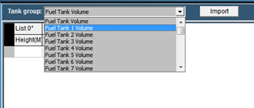

Figure 3‑27: Tank Group Drop Down

You’ll notice it only shows the tank group volumes, as that is what you get in the sounding table. As mentioned earlier with height and volume, FT NavVision © can calculate all the other values.

Now that you have chosen the right tank, you can manually fill in the diverse heights and volumes. Make sure you start with “0” and end with the highest value or your value will be the wrong way around.

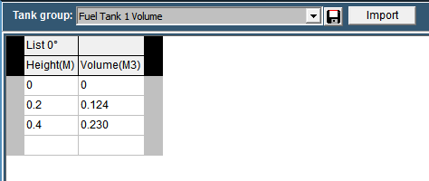

Figure 3‑28: Filling in tank tables

As soon as you start filling in the numbers you will see a “save button” appear next to the drop down menu (see Figure 3‑28). With this button you can save the calibration table to the specific tank. FT NavVision © will immediately start working with this values.

Of course filling in large amounts of data like this will be quite time consuming. Therefor it is possible to import the data from an excel sheet providing the excel sheet is setup the right way.

#### Excel import

Most times the calibration tables or sounding tables will be available in some kind of excel format. It is wise to start with a new excel-sheet where you transfer the data from the sounding tables to, one by one. You can name the different tabs to the “trim” and “list” (see Figure 3‑29).

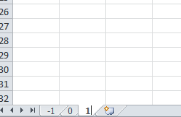

Figure 3‑29: Excel tabs

So for an example list we take the following sounding table:

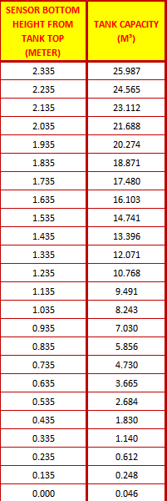

Figure 3‑30: Example Sounding Table

As you can see it goes from high to low, which is the wrong way around, but we change that later. First select all the values and “control-c” to copy the data. Go back to your original excel document and paste it on the SECOND row (see Figure 3‑31).

*: Use Paste Special “values” or “Unicode”*

*: in the first row you need to use an empty cell and the second cell with the “List” degree-number*

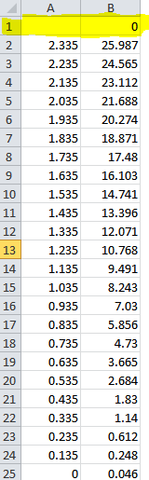

Figure 3‑31: Excel sheet import list

Now select all the values except for the upper row and choose “Sort>from low to high” to get the data in the right order. Once this is done you will have the right values for the list (see Figure 3‑32).

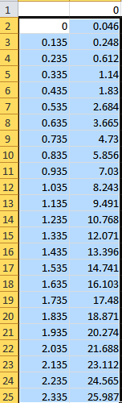

Figure 3‑32: Excel list sorted

Now save the new made table as “Excel97-2003 *.xls”file. In this case we name it “Fuel Tank 1”.

#### Import from excel

Now go back to the “tank tables” and click on “import”. Look for the excel file you just created and choose it for import. Click OK and the list will be imported and shown. (see Figure 3‑33).

At this time you can save the table and it will be used within the calculation of FT NavVision ©.

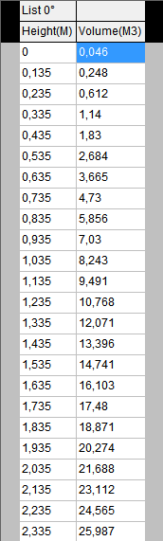

Figure 3‑33: Imported Table

### Trim and List

Ships move in different directions. They can roll over the latitude axis (the roll or list), or over the longitude axis (the pitch or trim). You can imagine that when the ship is moving, the liquids in the tanks will also move. This way the method of measuring with a pressure sensor will have some shortcomings.

For instance, when the ship is rolling over, the liquid column above the pressure sensor can alter. In this example it gets shorter (see Figure 3‑34). This way the calibration will alter. The pressure sensor thinks it has a smaller column of liquid and will refer to the calibration table. While the tank is abating here, there will be much more liquid available than the calibration table will say.

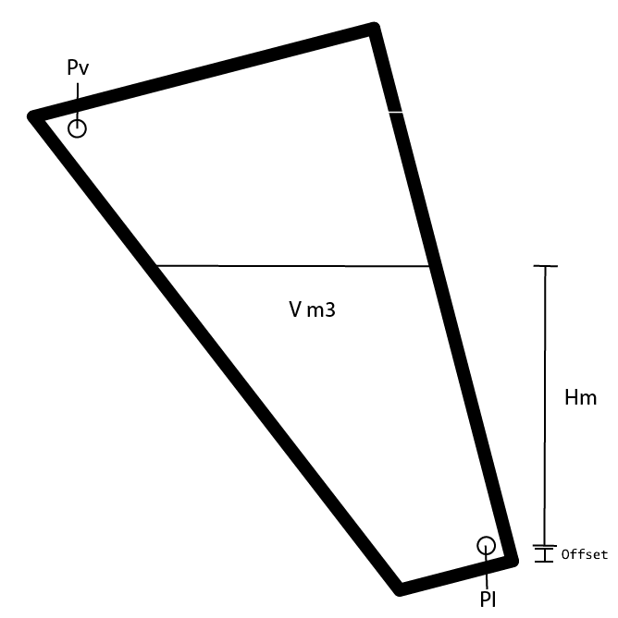

Figure 3‑34: Roll and Pitch

When an architect kept that in mind he surely will have the calibration or sounding table recalculated in different roll and pitch positions. This way you can make an even more accurate calibration.

#### Roll and Pitch in the Tank Table

In the tank table page you will find two “edit fields”. One for the Trim and one for the List. While Trim is the Pitch of the ship and List is the roll of the ship you can alter the number accordingly to the number of different sounding tables you have. If, let’s say, you have seven Trim Tables, fill in the number “3” and press “submit”. You’ll notice that there are now three tabs on either side of the 0-degree tab. -3,-2,-1,0,1,2 and 3 degree. (see Figure 3‑35). For this you need to have 7 different sounding tables from the architect.

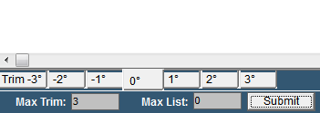

Figure 3‑35: Max Trim

Now let’s say that you have only three sounding tables for the roll (List). Fill in the number “1” and press “submit”. Now you will have three different columns for the sounding tables of the “List” -1,0 and 1 degree (see Figure 3‑36).

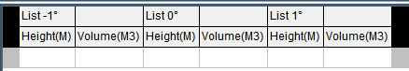

Figure 3‑36: Max List

This way you’ll have 3 different “list” columns for 7 different “trim” tabs so 21 different calibration points (see Figure 3‑37). In this ideal configuration you will have a very accurate calibration.

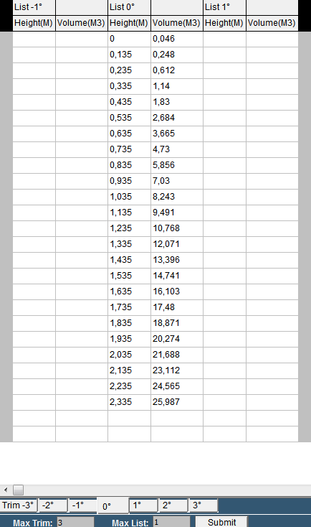

Figure 3‑37: Trim/List example

#### Trim and list in Excel

When you are importing sounding tables through an Excel list you would like to put in the trim and list at the same time. This is possible by doing the following:

Taken the previous as example you will have to make 7 tabs and rename them according to the degrees in the sounding table. For the trim you will make a column for each degree that you have in the sounding table and rename these in the upper row right cell of each separate column (see Figure 3‑38).

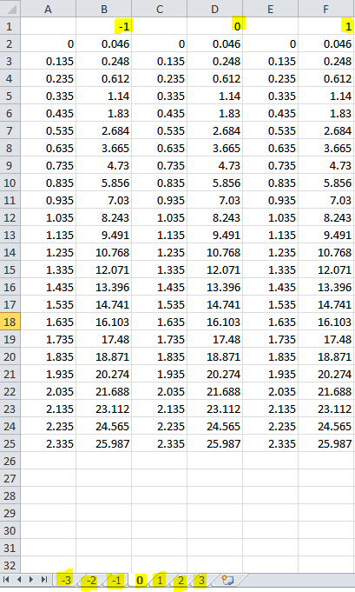

Figure 3‑38: trim and list excel example

Now save the excel sheet, import it in the tank table page, save it and you will have all the data ready to be used by FT NavVision © (see Figure 3‑39)

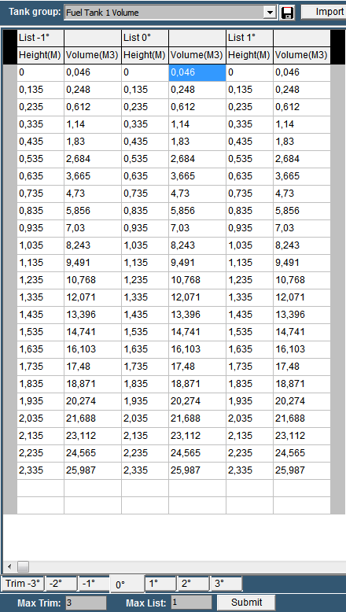

Figure 3‑39: Tank Table excel Trim and List import

Free Technics

Technical & customer support **The Netherlands**

Free Technics B.V.

Eikenlaan 259J

2404 BP, Alphen aan den Rijn

The Netherlands

Telephone: +31 172418 890

Fax: +31 172418 899

www.freetechnics.eu